SEO METADATA
- SEO title (52 chars): Church Translation Equipment: Hardware vs AI Options
- Meta description: Compare church translation headsets, receivers, transmitters, and AI-based systems. Learn real setup trade-offs, recurring costs, and buying criteria.
- URL slug: /blog/church-translation-equipment/
- Primary keyword: church translation equipment
- Unique primary search intent: Research and purchasing preparation. "What gear do we need, what will it cost to own, and how do we choose?" Setup steps belong to /blog/sermon-translation-guide/, system selection belongs to /blog/church-translation-system/, and the commercial pitch belongs to https://exbabel.com/solutions/churches/.
- Secondary phrases used naturally: translation equipment for churches, church interpretation equipment, church translation receivers, wireless interpreter headset, church translation transmitter, USB audio interface church, church translation equipment cost
- Author disclosure: Published by Exbabel.
- Suggested schema: Article + FAQPage (use the five FAQ items below).

Church Translation Equipment: Hardware vs AI Options
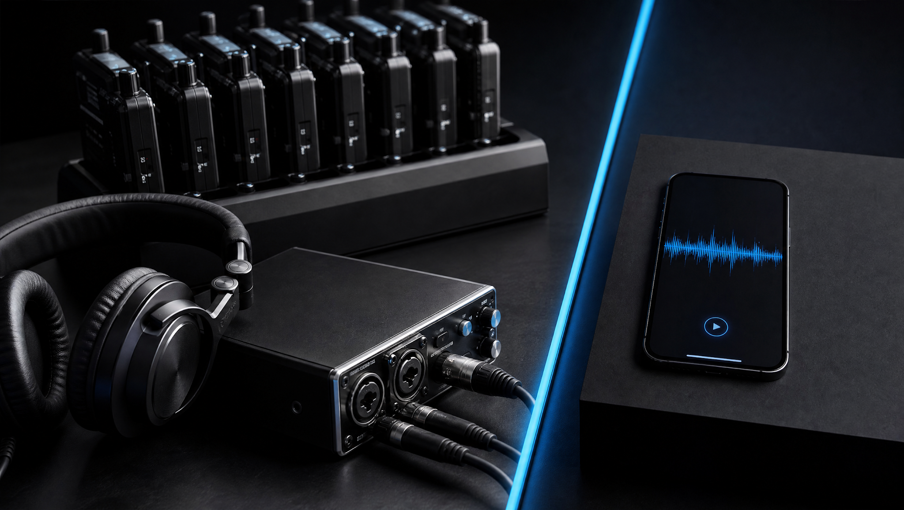
Sunday, 9:40. A visitor hovers by the welcome desk and asks, "Anything in Spanish?" It's a question churches hear more often than you'd expect, because about 21.7% of people age five and older speak a language other than English at home, according to Census Bureau figures for 2018 to 2022. So what equipment actually closes that gap?
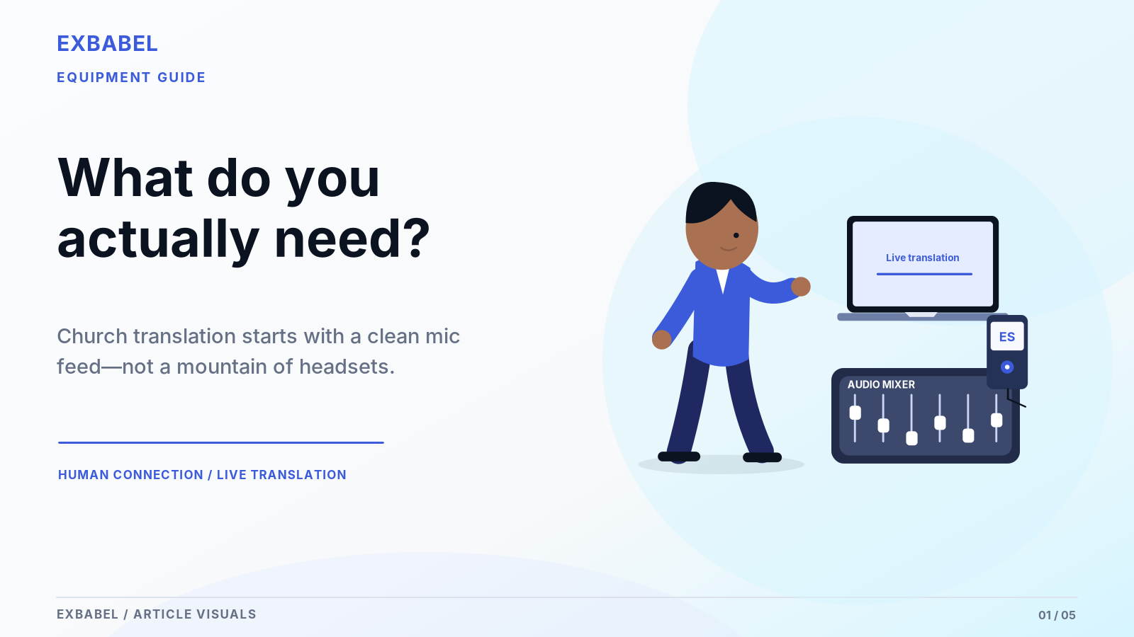

What Equipment Does a Church Need to Translate Services?
In short, a church needs a translator, a way to carry the sound and something for each listener to hear it on. The traditional route pairs a live interpreter with a transmitter and receivers. The newer route replaces both with software and the phones people already carry. Either way, a clean microphone feed comes first. Either way, something can go wrong, from a dead battery to a moody Wi-Fi signal. Let's walk through each piece.

Key Takeaways
- Equipment never translates on its own, because people or software do that job.
- Receiver kits skip the internet but add batteries, chargers and storage.
- Phone-based AI trims the receiver pile. You still need a decent mic feed, a computer and a plan B.
- A three-year total tells you more than the first invoice.
- Keep loaner receivers or wired earbuds ready for guests without smartphones.
Let's start with what the gear in a traditional setup actually does.

What Is Church Translation Equipment?
Say "translation equipment" and most people picture a crate of headsets. In practice the phrase covers two jobs (translating the words and moving the audio) and confusing them is how churches overspend.

Interpreters and Speech Pickup
Everything begins with a person. A bilingual interpreter listens to the pastor and speaks the translation into a headset microphone. ChurchLeaders describe that person working from the sound booth, the sanctuary or a soundproof booth with an audio feed. Here's the part the brochures skip: the gear never translates a word on its own. Glossa makes the same point. Without a second-language speaker, even a great transmitter just broadcasts silence.

Transmitters, Frequencies and Receivers
The interpreter's microphone feeds a transmitter, which sends the voice on a channel. Receivers tuned to that channel pick it up, each with a volume knob and a headphone jack. ChurchLeaders notes that one system can carry up to six languages, though each needs its own interpreter and channel. Think of it as a tiny radio station that only your congregation can hear. Frequency rules vary. Check yours before buying.

Attendee Headphones and Distribution
Receivers are only half the story, because listeners also need headphones or earbuds. Somebody has to hand them out and collect them again after the benediction. Glossa mentions charging cases and the chore of managing batteries, which sounds minor until you do it every Sunday. A kit that sits in a closet from Monday to Saturday still needs one person who remembers to charge it and count the strays.

Hardware Options and Where They Work
Three styles dominate right now: radio kits, infrared installs and phone-based networks. Each suits a different kind of building. Match the style to your room before you start comparing brands.
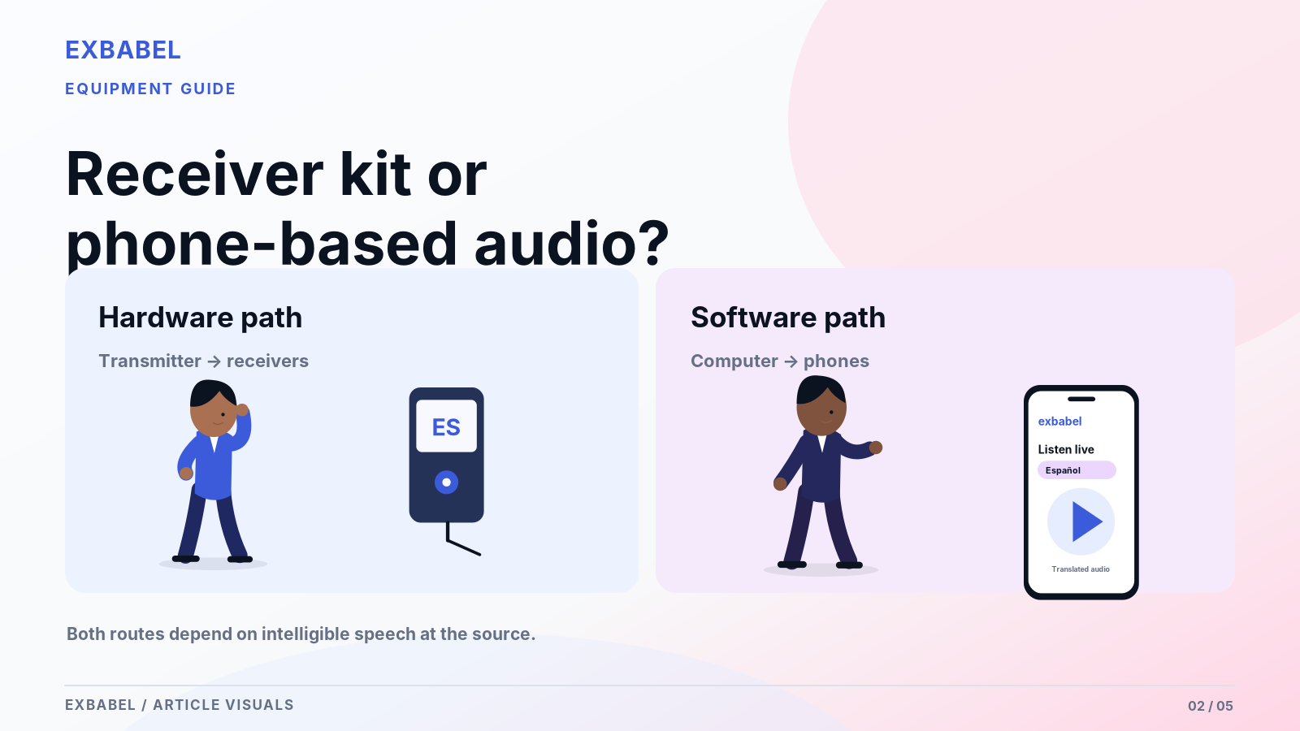

RF/UHF Receiver Kits
Radio kits are the familiar choice. ChurchLeaders recommends FM for most churches and favors analog units on price. Receivers work without the internet, which matters when your building has weak Wi-Fi. The trade-off is hardware you own. Batteries die mid-offering and receivers occasionally wander home in coat pockets. Ask any supplier about channel limits for your room and get the answer in writing. Then test one unit from your worst corner.

Infrared and Installed Systems
Infrared sits at the other end of the spectrum. ChurchLeaders suggest it when a room needs more than six languages or extra privacy. Installed systems suit buildings with long leases whereas portable churches rarely want that commitment. A rented school gym is a poor fit. Mounting and line-of-sight needs vary by product. Ask the installer to survey your room and put both in writing before you sign.

Networked and Phone-Based Distribution
Here the audio rides your network to phones people already carry. Exbabel's guide describes listeners scanning a QR code or opening a link in a browser, with no dedicated receiver. That convenience comes with a dependency, because a network outage stops delivery cold while local radio doesn't care about your Wi-Fi. Weigh that before you retire receivers. Then test the network from the pews, not the office down the hall.

Software-Driven Translation: Different Equipment Needs
Software retires the interpreter and most receivers. It doesn't retire everything else. Three pieces of gear still matter. Any one of them can bite you on a Sunday morning.
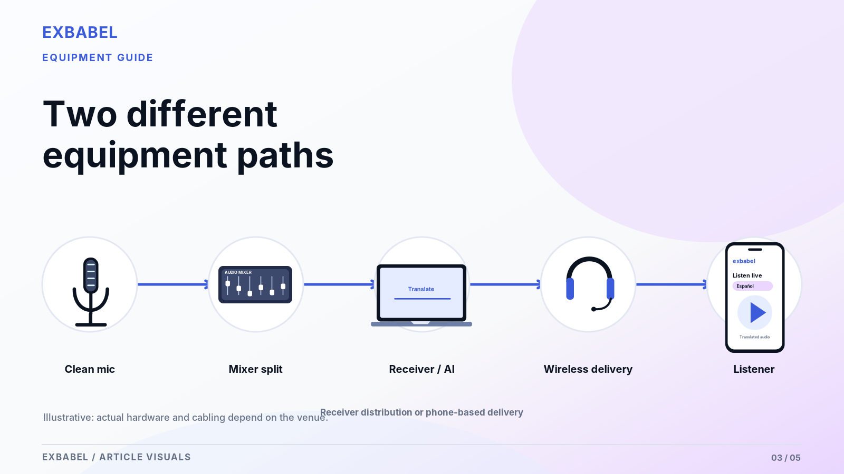

Pastor Mic and Mixer Output
It all starts at the pastor's microphone, same as before. Garbage in means garbage out. Exbabel's guide suggests a separate balanced speech feed or auxiliary output so music and room noise stay out of the mix. A smaller church can plug one microphone straight into a computer. Bigger rooms usually pull a clean feed off the mixer. Our sermon translation guide walks through the cabling and levels step by step.

Computer and USB Capture Path
Next, that feed has to reach a computer. Some mixers offer native USB audio while others need a separate USB audio interface. Exbabel's guide also mentions Dante network audio and RTMP encoders such as OBS, vMix and Wirecast for larger setups. Buy a computer you trust and think about a spare. Then test your exact hardware chain, because a spec sheet can't tell you how it behaves in your booth.

Listener Phones, Earbuds and Wi-Fi or Cellular
Listeners bring their own phones and earbuds, then join over church Wi-Fi or cellular data. Guest networks sometimes block traffic. Offer the cellular route too. Mention it in announcements. Exbabel's guide admits that attendees without smartphones may still need translation headphones. That's fair. It's also why a small pool of loaner receivers or wired earbuds earns its shelf space. Nobody should sit through worship without access.

Itemized Cost Comparison for Church Translation Equipment
No honest price exists without your own quotes. So this section gives you the structure instead. Fill each line with written quotes that show dates, units, currency and assumptions.
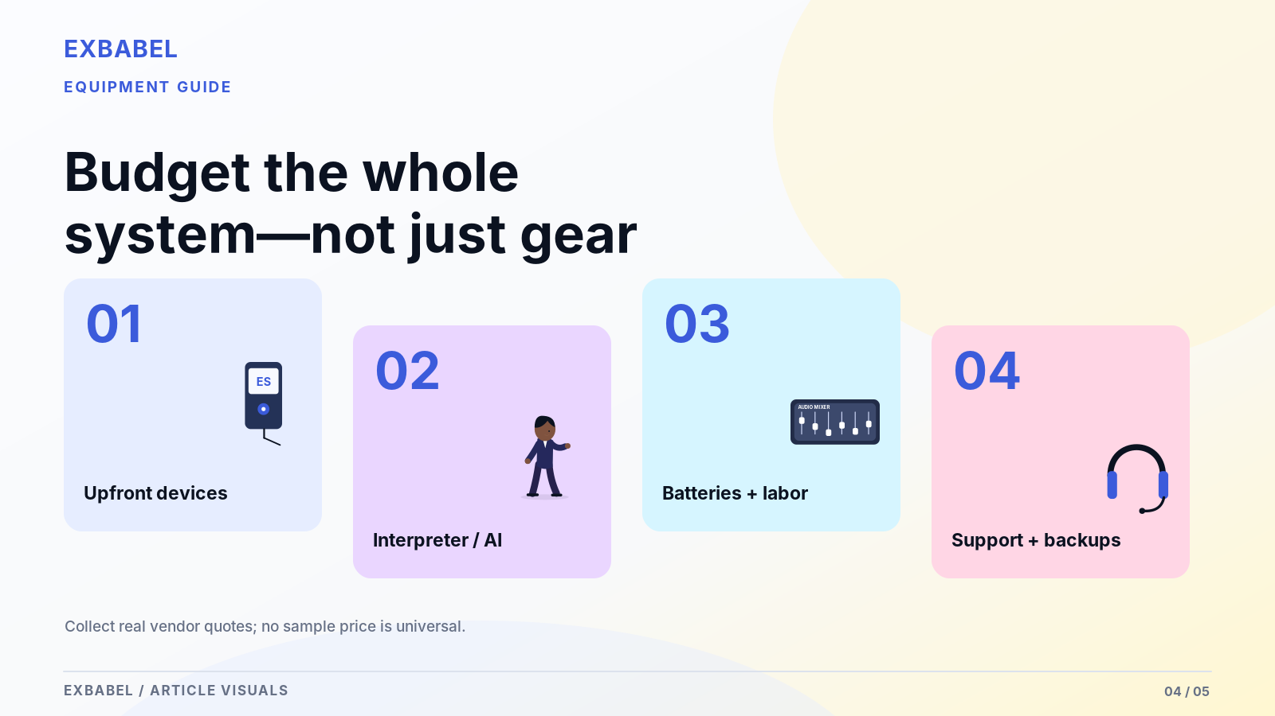

Upfront Purchases: Transmitters and Receivers
Hardware cost starts with a transmitter, a receiver for every listener and headphones to match. Glossa lists example packages of one transmitter with 10 or 20 receivers plus a charging case. Prices vary by vendor and change often. This article quotes none. Ask at least two suppliers for written quotes. What's included? What costs extra? How long does the warranty run? Then record every answer in the table below.
Item | Quantity | Unit price | Price source | Quote date | Included or extra
Transmitter
Receivers
Headphones or earbuds
Interpreter headset microphone
Charging case
USB audio interface (if needed)
Spare computer or laptop (if needed)

Recurring Items: Interpreting Labor, Subscription and Consumables
Recurring costs hide in plain sight. Hardware means batteries, repairs, replacements and interpreter time, whether paid or volunteer. Software means a subscription that's often tied to hours or languages. Confirm it on the vendor's current plan page. Volunteer hours still cost something even at zero dollars. Burnout is the pricey part. Write down who interprets, how often and what happens when they get sick. Then keep that note somewhere findable.

Three-Year Model and Breakeven Inputs
Add the upfront cost to three years of recurring cost for each route. Then divide by the number of services you actually run. That figure tells you more than any sticker price. Breakeven shifts with languages, attendance and interpreter pay. Nudge one input and the answer moves. Use the worksheet below with your own numbers. Skip any promise of a percentage saved. Be honest with the inputs.
Input | Radio or infrared kit | Phone-based AI | Hybrid
Upfront purchases
Year 1 recurring cost
Year 2 recurring cost
Year 3 recurring cost
Three-year total
Services per year
Cost per service
Languages covered
Average listeners per service

Performance and Accessibility
Cost is only half the decision. Performance in your actual room matters just as much. So does who can use the system, which is a separate question from language.

Languages, Channels and Scalable Staffing
Hardware scales with people. Each language needs its own interpreter and channel, as ChurchLeaders explains. Staffing grows with every language you add. Software scales differently because a new language doesn't need a new person. Language availability and voice options still depend on the plan, though. Confirm your priority languages well before launch. Then test each one with a native speaker. That takes time. Book it early.

In-Room Signal Stability vs Internet Dependency
Radio and infrared stay inside the building. They don't need your router. Phone-based delivery needs a working network. A clean one, too. Exbabel's guide points to automatic failover and buffering for unstable connections. That helps but doesn't make an outage harmless. Test both options from the farthest seat during a busy service. Then decide how much risk your congregation can live with. Write down what you find.

Human Nuance and Accessible Communication Needs
A skilled interpreter hears what's meant behind what's said. Software can miss that nuance. Test it on doctrine and names. Keep a person involved at funerals, weddings and hard conversations. Don't mix up listening receivers with sign language either. Neither a receiver nor an app replaces a qualified signed-language interpreter or settles accessibility obligations. Ask a qualified accessibility professional what your congregation needs before you buy.

What a Church Should Buy: Decision Paths
There's no universal winner. The right buy follows your languages, your room and your volunteers. Here are three common situations with conditional advice instead of brand picks.

One Language and a Volunteer Interpreter
Say your church adds one Spanish service and a dependable volunteer steps up. A basic receiver kit may be all you need. It works without the internet. The interpreter's voice stays human. Check the volunteer's schedule first, though. What happens if that one person moves away? Our church interpreter vs AI translation comparison helps you plan for that day. It's a boring question until it isn't. Plan for it now.

Multiple Languages and Rotating Visitors
Now flip the situation. Visitors speak many languages and change every month. Hiring an interpreter per language gets hard fast. Phone-based AI audio and captions can cover more languages without more staff. Keep a small receiver pool for people without smartphones and keep a human option for sensitive moments. Mixed models often suit this kind of church best. Test each language before you announce it from the pulpit.

Multisite and Broadcast Services
Several campuses or a livestream raise a new question: where does the translation travel? Radio stays local to each room. Phone-based delivery can follow your stream anywhere. Exbabel's guide mentions embedding a multilingual player on a website and sending translated HLS feeds into an existing church app. Verify those paths with your own broadcast team before you promise anything to remote viewers. They deserve the same care.
Situation | Lean toward | Watch out for
One language, reliable volunteer | Receiver kit | Single point of failure if the volunteer leaves
Many languages, changing visitors | Phone-based AI plus a small receiver pool | Internet dependency and plan limits
Multiple campuses or livestream | Phone-based delivery with local fallback | Testing each room and the stream path

Procurement and Service-Day Checklist
Buying goes better with a script. These three habits protect your budget and your Sunday. A scorecard at the end turns them into numbers a committee can compare.
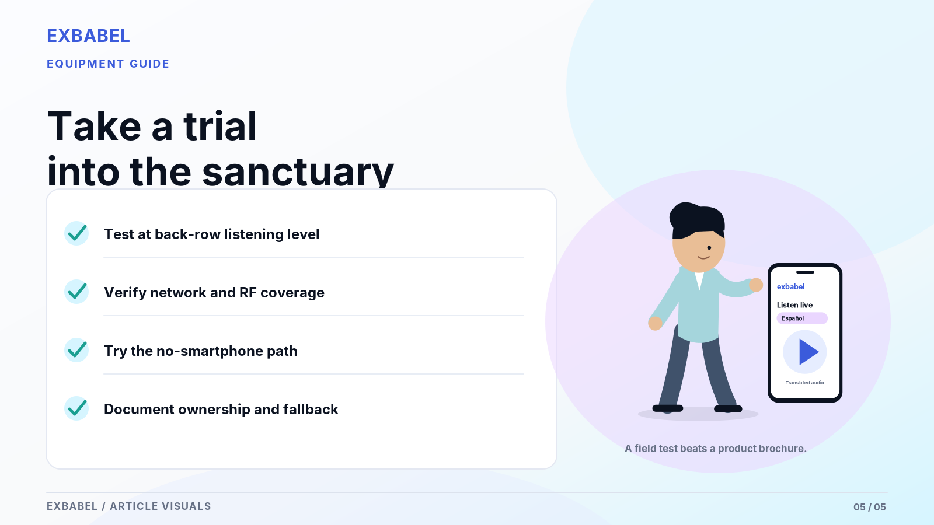

Ask Vendors for an On-Site Trial
Never buy a brochure. Ask every vendor (hardware or software) for a trial in your actual sanctuary. Many offer trials or loaners. Get it in writing. Two weeks beats two hours. Bring your own microphone, mixer feed and a bilingual listener. Run a real sermon, not a demo clip. A product that dazzles in a showroom can fall flat behind your pulpit. Jot down setup time and surprises.

Test Reception, Audio Quality and Attendee Experience
Walk the room with a receiver or a phone in hand. Listen from the back row, the balcony and the seat nearest the sound desk (that seat is its own weather system). Does audio stay clear? Do captions keep up? Then hand the device to a first-time visitor and watch quietly. Their hesitation shows you which instructions are missing. Jot down what you hear, plus the date and settings.

Backup Plan and Inventory Ownership
Decide who owns the gear before it breaks. Name one person for charging and one for counting returns. Keep spare batteries or earbuds, plus a printed fallback for outages. If you run software, note who holds the account login and who can restart a session. Gear without an owner becomes gear that's missing on Sunday. Tape a one-page checklist beside the sound desk, because nobody reads the binder.
# | Criterion | Weight (1 to 5) | Radio or infrared kit (score) | Phone-based AI (score) | Hybrid (score)
1 | Languages needed now
2 | Languages likely within three years
3 | Interpreter availability
4 | Audio capture quality in your room
5 | Ease of joining for first-time visitors
6 | Support for people without smartphones
7 | Reliability without internet
8 | Reliability on weak internet
9 | Setup time per service
10 | Volunteer training needed
11 | Upfront cost (written quote)
12 | Annual operating cost
13 | Maintenance and replacement
14 | Accessibility fit (not a substitute for signed-language interpretation)
15 | Vendor trial and support responsiveness
Ready to compare notes? Review an Exbabel configuration against your existing AV system and bring your scorecard along.

Choosing Church Translation Equipment with Confidence
The best church translation equipment is the set you can run every Sunday without drama. Compare routes using your own room, your own languages and written quotes. Hardware and software can live side by side. Start with the scorecard, run one honest trial and let the numbers settle the argument.
- Fill in the three-year worksheet before you request any purchase.
- Run a trial in your own sanctuary with a real sermon.
- Keep a human fallback for sensitive moments.
- Revisit the scorecard each year as your congregation changes.
- Need a buyer's checklist? Read our church translation system guide.

FAQ

Do Church Translation Headsets Automatically Translate?
No. Headsets and receivers only deliver audio. A live interpreter or translation software supplies the translation. Glossa and ChurchLeaders both describe equipment that depends on a human interpreter.

What Equipment Still Needs to Be Purchased for AI Audio Translation?
You still need a microphone or mixer feed, a computer, a reliable connection and a way to share the QR code. Larger rooms may add a USB audio interface or network audio. Listeners bring phones and earbuds. Keep a few loaners on hand.

What Happens When Wi-Fi Goes Down?
Phone-based delivery pauses or degrades. Radio and infrared receivers keep working because they don't use your network. Keep a cellular hotspot, a printed fallback and a briefed bilingual usher ready. Rehearse the switch once.

Are RF Receivers Better for People Without Smartphones?
Often yes. They need no phone, data plan or browser. The trade-off is managing the units. Many churches keep a small pool of receivers beside phone-based delivery.

How Do We Compare Per-Language and Per-Attendee Costs?
Use the three-year worksheet. Divide total cost by languages served, then divide by average listeners using translation. Hardware cost grows with interpreters and receivers while software cost depends on plan terms. Use written quotes only.
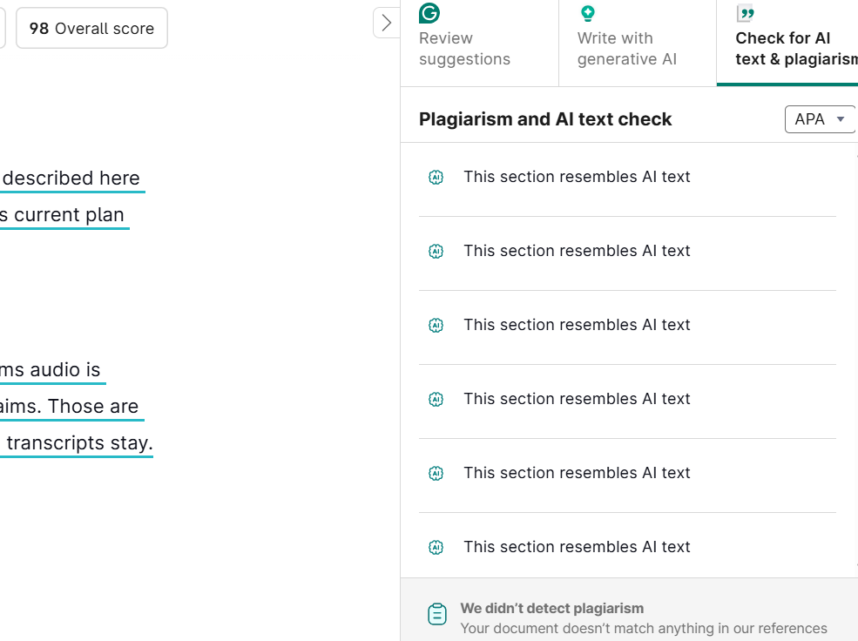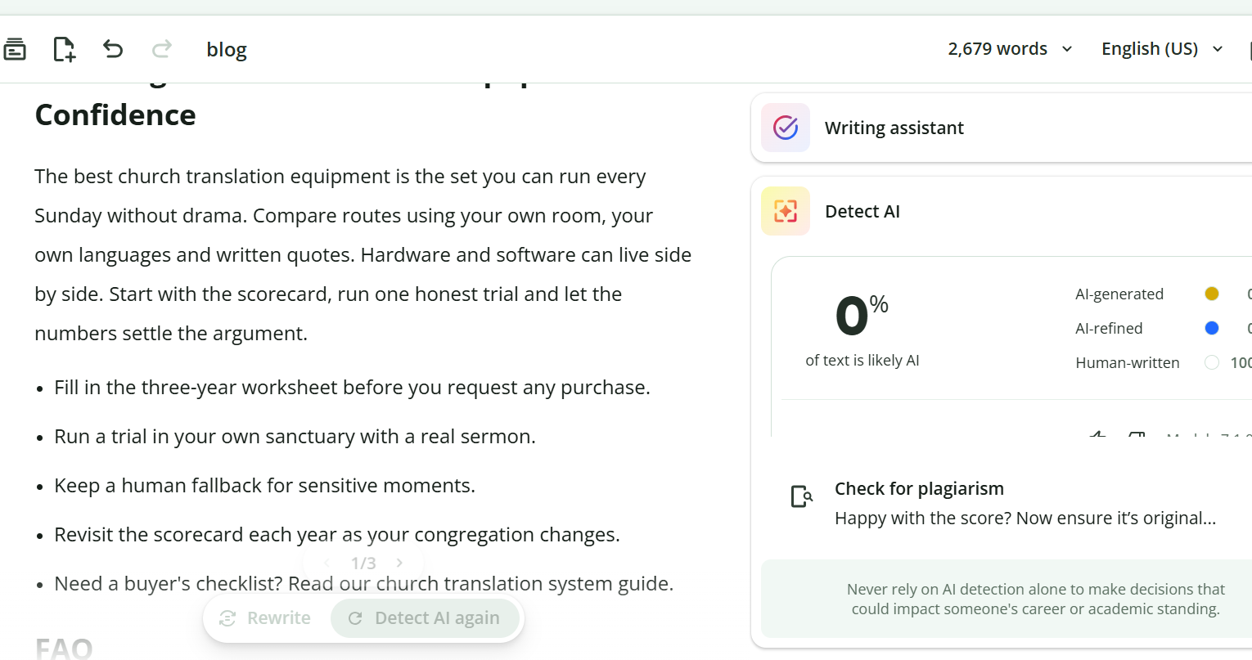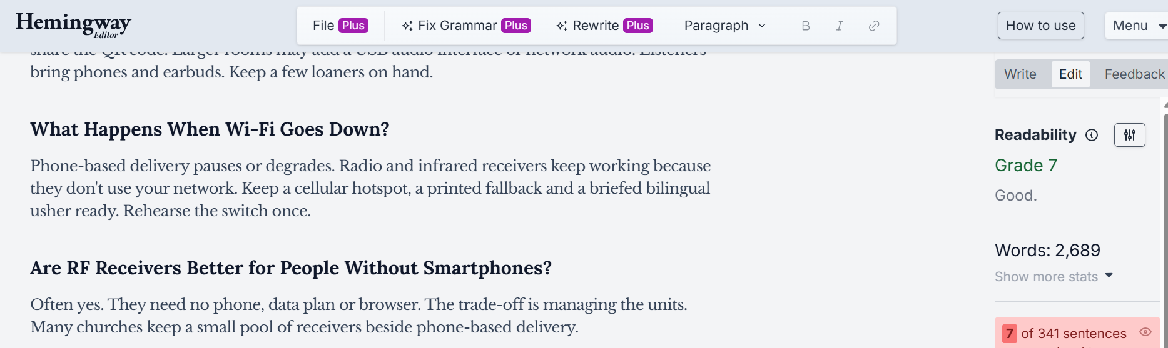
Further reading (external, descriptive anchors):
- ChurchLeaders on selecting a church translation system: selection criteria such as FM versus infrared and single versus multi-channel.
- Census Bureau on language spoken at home: the population figure used in the introduction.
- ADA.gov on effective communication: auxiliary aids, including qualified interpreters, as context for the accessibility section.
Published by Exbabel.

IMAGE AND RESOURCE RECOMMENDATIONS (with alt text)
# | Asset | Placement | Alt text
1 | Original comparison chart with two physically separate paths. Path A: pastor mic, mixer, interpreter headset, transmitter, receivers, listener. Path B: pastor mic, mixer, USB interface, computer, Exbabel, listener phone. Label "illustrative" until a sound engineer checks it. | After the "Hardware Options and Where They Work" intro | Diagram comparing a receiver-based translation path with a phone-based translation path
2 | Photograph of a real receiver kit (transmitter, receivers, charging case) with usage permission | "Transmitters, Frequencies and Receivers" | A church translation transmitter, receivers and charging case laid out on a table
3 | Screenshot of the current Exbabel attendee join flow (QR scan, language choice, play) with version and date | "Networked and Phone-Based Distribution" | Phone screens showing a visitor scanning a QR code and choosing a translation language
4 | Bill-of-materials table (in the article) filled with real quotes, price source and date | "Upfront Purchases" | Table listing transmitter, receivers, headphones and other items with quote sources and dates
5 | Downloadable procurement decision matrix (the 15-criterion scorecard as a spreadsheet) | End of "Procurement and Service-Day Checklist" | Scorecard comparing receiver kits, phone-based AI and hybrid setups across fifteen criteria
6 | Downloadable three-year ownership calculator (the worksheet as a spreadsheet) | "Three-Year Model and Breakeven Inputs" | Worksheet for adding upfront and recurring translation costs over three years

SOURCE LOG (accessed October 18, 2026)
Source | URL | Used for | Claim type
Glossa, church translation equipment guide | https://glossa.live/blog/translation-equipment-churches-guide | Equipment does not translate automatically; transmitter, receiver and headphone flow; charging cases and battery chores; example packages of one transmitter with 10 or 20 receivers | Vendor content
ChurchLeaders, How to Select the Best Church Translation System (Duke Taber, March 6, 2025) | https://churchleaders.com/ministry-tech-leaders/404837-how-to-select-the-best-church-translation-system.html | Headset mic, transmitter, receivers; interpreter location; up to six languages per system with separate interpreter and channel; FM recommended for most churches; analog favored on price; infrared for more than six languages or privacy | Editorial article
Exbabel church translation system article | https://www.exbabel.com/blog/church-translation-system/ | Speech feed advice; USB interface, Dante, RTMP encoders (OBS, vMix, Wirecast); QR or link in a phone browser, no dedicated receiver; headphones may still be needed for people without smartphones; failover and buffering; embeddable player and HLS feeds; voice availability varies by plan | Exbabel documentation (re-verify before launch)
Exbabel, Church Interpreter vs AI Translation (published September 21, 2026) | https://www.exbabel.com/blog/church-interpreter-vs-ai-translation/ | Internal link target; hybrid framing | Exbabel content
Wordly Help, place-of-worship setup | https://help.wordly.ai/setting-up-wordly-for-your-place-of-worship | Further reading; reusable weekly session; separate AV guide | Vendor documentation
Hope Translator, live sermon translation | https://www.hopetranslator.com/resources/live-sermon-translation | Further reading; QR broadcast and soundboard advice | Vendor claim
Census Bureau press release CB23-208 (December 7, 2023) | https://www.census.gov/newsroom/press-releases/2023/language-at-home-acs-5-year.html | About 21.7% of people age 5 and older spoke a language other than English at home (2018 to 2022 five-year estimates; derived from 78.3% English only) | Government statistics
ADA.gov effective communication | https://www.ada.gov/resources/effective-communication/ | Qualified interpreters as a distinct auxiliary aid (context only) | Government guidance
Exbabel Top 7 Expanded SEO Editorial Briefs (Brief 02) | Client brief | Outline, guardrails, CTA rule, internal links | Client brief
Deliberately not used: every hardware price range and interpreter rate on Glossa's page (undated, partly unreadable); the FM range figure and battery-count example on that page; Glossa's accuracy and language-count claims; Exbabel plan prices and trial terms (change often; the brief bars unsourced prices); Exbabel's speech and caption timing figures; any language count; ChurchLeaders' FCC remarks and its statement that no AI product can translate (dated March 2025); any claim that AI replaces signed-language interpretation or satisfies accessibility rules.

VERIFICATION CHECKLIST
- Publish order: /blog/sermon-translation-guide/ (Article 1) should be live before this article links to it.
- Collect written quotes from at least two hardware suppliers and one interpreter service, then fill the bill-of-materials table with price source, date, units and currency.
- Photograph a real receiver kit and the current Exbabel attendee join flow, with usage permission (images 2 and 3).
- Have a sound engineer check the comparison diagram, cables, line levels and connector types (image 1).
- Re-verify the Exbabel statements (Dante, RTMP encoders, failover and buffering, embeddable player, HLS feeds, headphones for people without smartphones) against the current product before publishing.
- Confirm browser compatibility of the listener flow on current iPhone and Android versions.
- Confirm the Census statistic is still the latest release and keep the "2018 to 2022" wording accurate.
- No frequency, range, battery-life or regulatory claims are made. Keep it that way; have vendors state them in writing.
- Have an accessibility professional review the "Human Nuance and Accessible Communication Needs" section. It makes no compliance claims.
- Confirm Exbabel is comfortable linking to Glossa, Wordly and Hope Translator, and referencing ChurchLeaders.
- Confirm the church landing page link (https://exbabel.com/solutions/churches/) is the preferred destination for the product CTA.
- Build the downloadable decision matrix and three-year calculator from the in-article tables.
- Confirm the "Published by Exbabel" disclosure.
- Check the new slug against existing Exbabel content for intent overlap with /blog/church-translation-system/.

